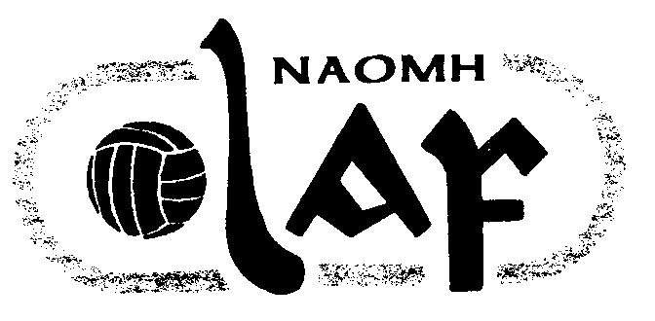
NAOMH OLAF GAA CLUB
Peil (Football)/ Iomaint (Hurling) Fixtures 2004

Roinn  (Age) | La  (Date) | Am  (Time) | I gCoinne  (Opposition) | Ionad  (Venue) | Comortas  (Competition) | Naomh Olaf Score | Opposition Score
U13 F | Tues 4th | 7.00 | St Mark’s | Pairc Ui Bhriain | League
Minor F | Tues 4th | 7.15 | Cuala | Hyde Park | League | 2-14 | 1-8
U12 H | Wed 5th | 7.00 | Kilmacud Crokes | Pairc Ui Bhriain | League
Ladies Senior F | Wed 5th | 7.00 | Man O War | Pairc Ui Bhriain | Cup | Off | Off
U16 H | Thurs 6th | 7.30 | Castleknock | Porterstown | League | Off | Off
U14 Ladies F | Fri 7th | 7.30 | Cuala | Hyde Park | League
U9 F | Sat 8th | 11.30 | Ballinteer St John’s | Broadford | League | 4-1 | 3-1
U12 F | Sat 8th | 12.00 | Liffey Gaels | Liffey Park | League | 7-3 | 5-3
U14 H | Sat 8th | 3.30 | Faughs | Pairc Ui Bhriain | League | Loose | Win
U10 F | Sun 9th | 10.15 | Bray Emmets | Marley Park | Shield | 6-2 | 2-1
Minor F | Sun 9th | 11.00 | Ballymun Kickhams | Pairc Ui Bhriain | League | 1-4 | 2-9
Adult Div 2 F | Sun 9th | 11.30 | Nh Fionnbarra | Parnell Park | Championship | 1-10 | 1-10
U16 Ladies F | Sun 9th | 4.30 | St Sylvester’s | Broomfield | League | Loose | Win
U12 Ladies F | Sun 9th | 6.30 | Clontarf | Pairc Ui Bhriain | League
U18 Ladies F | Mon 10th | 7.30 | St Brigid’s | Russell Park | League | 8-13 | 1-3
Ladies Senior F | Wed 12th | 7.00 | Naomh Barrog | Pairc Barrog | Cup

